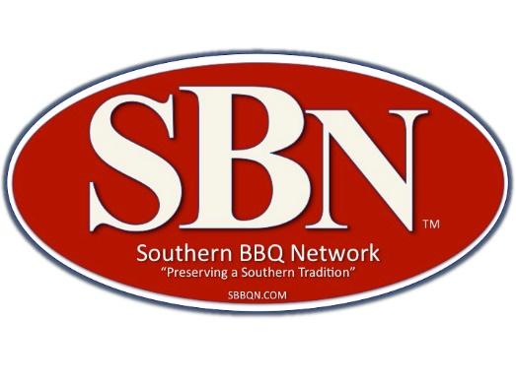
SOUTHERN BBQ NETWORK EVENT RULES
- COOK TEAM(S)
● A cook team is any individual, group, restaurant, etc. hereinafter referred to as a team that prepares and cooks an entry or entries for the purpose of being judged according to SBN rules at an SBN sanctioned event.
● Each team is comprised of a head cook and as many assistants as required. The event organizer, of an SBN sanctioned event, may NOT cook in any category in that event.
● Each team should have at least one representative present at the cooks’ meeting held the evening prior to the event. Cook teams, absent from the meeting, accept the responsibility for understanding these rules and any changes to them that may have been incurred.
● Teams, including members and guests, are expected and required to exhibit proper and courteous behavior at all times. Teams are expected to comply with “quite time” stipulations as set by the event organizer. Teams will be advised of local laws and will adhere to these laws. Failure to abide by these rules of behavior may result in expulsion from the event and may be barred from competing in SBN sanctioned events.
● No cook team member of an SBN sanctioned event may enter the judging or scoring area during the event.
2. SITE LOCATIONS, SANITATION AND SAFETY
● Each team is assigned a cook site. Teams’ equipment including cooker, canopy, trailer, etc., should be contained within this space. If additional space is required the team should contact the event organizer to make satisfactory arrangements.
● Teams are expected to maintain their cook sites in an orderly and clean manner and are responsible for cleanup of their site once competition ends.
● Sanitary practices as prescribed by State Health Departments regulations are to be observed during preparation and cooking processes. All cooking, seasoning, marinating or injecting must be done on site. Plastic or rubber gloves should be used at all times while handling food. A meat thermometer, a five gallon hand washing station with soap, flowing water and paper towels shall be available on your site.
● Each site should have a #10 A-B-C fire extinguisher. Adequate space will be provided to each cook team for this added fire code provision. Event organizers will explain local fire codes as applicable.
3. EQUIPMENT
● Each team shall supply all equipment necessary for preparation and cooking of their entry including a cooker and cooking fuel. No team may share a cooker or grill with any other team.
4. JUDGING AND SCORING
● Categories of meats sanctioned for judging by SBN are as follows:
a. Pork – butts or whole hog
b. Pork ribs – bone in, excluding county style ribs
c. Chicken
d. Beef
● SBN uses a blind judging system.
● Entries are submitted in an approved turn-in container supplied by the event organizer, with no garnish, or decorations. Only samples for judging are allowed in the turn-in container. That is the only authorized container for sample turn-ins. Any turn-in container that inadvertently becomes damaged or could be considered as “marked” can be replaced by the SBN event representative. Marking is defined as any handwritten or mechanically made mark inside or outside the turn-in container that could identify the submitting team to a judge.
● The contents of turn-in containers become the property of the SBN at the moment they are placed at the receiving table.
● Meat may be sauced or un-sauced.
● Pork must be cooked intact. Money meat cannot be separated prior to doneness.
● A minimum of eight (8) separate and identifiable portions per turn-in container are required. In the case of pork butts and whole hog, the sample size is a minimum of 2 ounces of pork per servings. This can be in any form, pulled, chopped, medallions, etc.
● Turn in times are established by the event organizer. SBN allows for a ten minute window: five minutes before and five minutes after. Suggested turn-in times for categories have been:
a. Pork: 9 AM
b. Pork ribs: 10 AM
c. Chicken: 11 AM
d. Beef: 12 Noon
● Each entry is judged and scored using SBN’s criteria of appearance, taste/aroma, and texture/tenderness. SBN utilizes a one decimal point range scoring system from a low of 1.0 to a high of 10.0. Winners with the highest average scores are awarded first place; the team with the next highest average score receives second place, etc.
● Grand Champion and Reserve Grand Champion are teams with the highest sum of average total scores in the specified meat categories in the event.
● In the event of ties resolution is resolved by SBN’s scoring procedures.
5. DISQUALIFICATION
SBN’s event representative is the only person that can disqualify an entry. Any entry found to be disqualified will receive a score of 1.0 in a category.
● Evidence of Marking or sculpting. Sculpting is defined as: carving, decorating, forming or shaping of a meat sample, contained in a turn-in container, which could identify the submitting team to any judge. A box turned in upside down is considered a “Marked” box.
● No garnish of ANY kind allowed. Foreign material in the turn-in container. Brush bristles toothpicks and aluminum foil are examples of foreign material.
● Less than eight (8) individual SEPARATE number of samples.
● Evidence of blood such as the meat is prepared below State Health Department’s safe consumption guidelines.
● Entries turned in after the designated turn-in time will be disqualified for that category.
● “In the event a cook team is disqualified for violation of the events published rules, SBN will abide by the events decision and the actions they impose”

6. INTERPRETATION OF RULES
● The interpretation of SBN rule(s) are those of SBN’s event representative at each event and their decisions are final.

Violation of the rules may result in disqualification from an event.

